Power and Hardware Solutions – Research

Bridging the Digital Divide

Unit: COIT13236

Group: G06-DST-UG25T2

Student 1: Shahriar Haque - S0259035

Project Mentor: Ahmad Saeed ([a.saeed@cqu.edu.au](mailto:a.saeed@cqu.edu.au))

Date: 31-08-2025

CQUniversity Australia

GitHub Repository: <https://github.com/cquict2025/nis-y25t2-project-g06-dst-ug25t2/tree/main>

## Introduction

The aim is to work out what the power requirements are of our chosen platform, the Raspberry Pi5. Find an appropriate solar battery requirement calculation and test if it can run with that solution. Noting down any challenges or issues that may arise.

## Hardware Requirements

Raspberry Pi

Rechargeable Battery

Solar Pannel

Weatherproof Protection

UPS

## Theory Prototype Calculations:

*There won’t be a monitor in the calculations as the idea is to use a battery monitor to bring out when having to do system maintenance rather than have one at each tower. Lowers upfront cost of scaled project and lowers battery consumption and panel requirements.

### Power Requirements:

Raspberry pi5 and a Power Bank

### Device Draw Amounts:

Adapter has a maximum capacity of 27w at 5v, however will test it via a plug running the software and get a more accurate measurement of its requirements as it wont be running full tilt.

### Battery Requirements:

60,000 mAh as battery's are only about 90% efficient with at least 27*9*1000/5 = 48600 mAh to keep it on for 9hrs for a night.

### Solar Requirements:

Location: Geraldton

Solar Pannels usually only get maximum sunlight for 5hrs a day, a 60000mAh battery for power over night and general rule of thumb a panel should produce about 20% more than your device and battery need as it can keep the devices running on lower functioning days/ weather. 27*16*1000/5

However Solar panels generally only get 6 good hours of sunlight a day of peak generation in Geraldton. Meaning a 27w device for 24hrs would equate to 648 or almost 650watt hours of power. Meaning you would need about a 110watt Pannel at minimum. But with the 20% rule of thumb, 780watt hours of power would require about a 130-watt panel.

*All these requirements are based on if the raspberry pi5 is running at maximum power and not actual numbers.

After testing, we will be able to find how much the raspberry pi5 draws in actual useage and work around those numbers (should be significantly lower than maximum).

## Testing:

Once acquiring an actual raspberry pi and battery and installing open wrt, the next step is to get real world numbers and calculate how much the devices do require.

Testing Setup: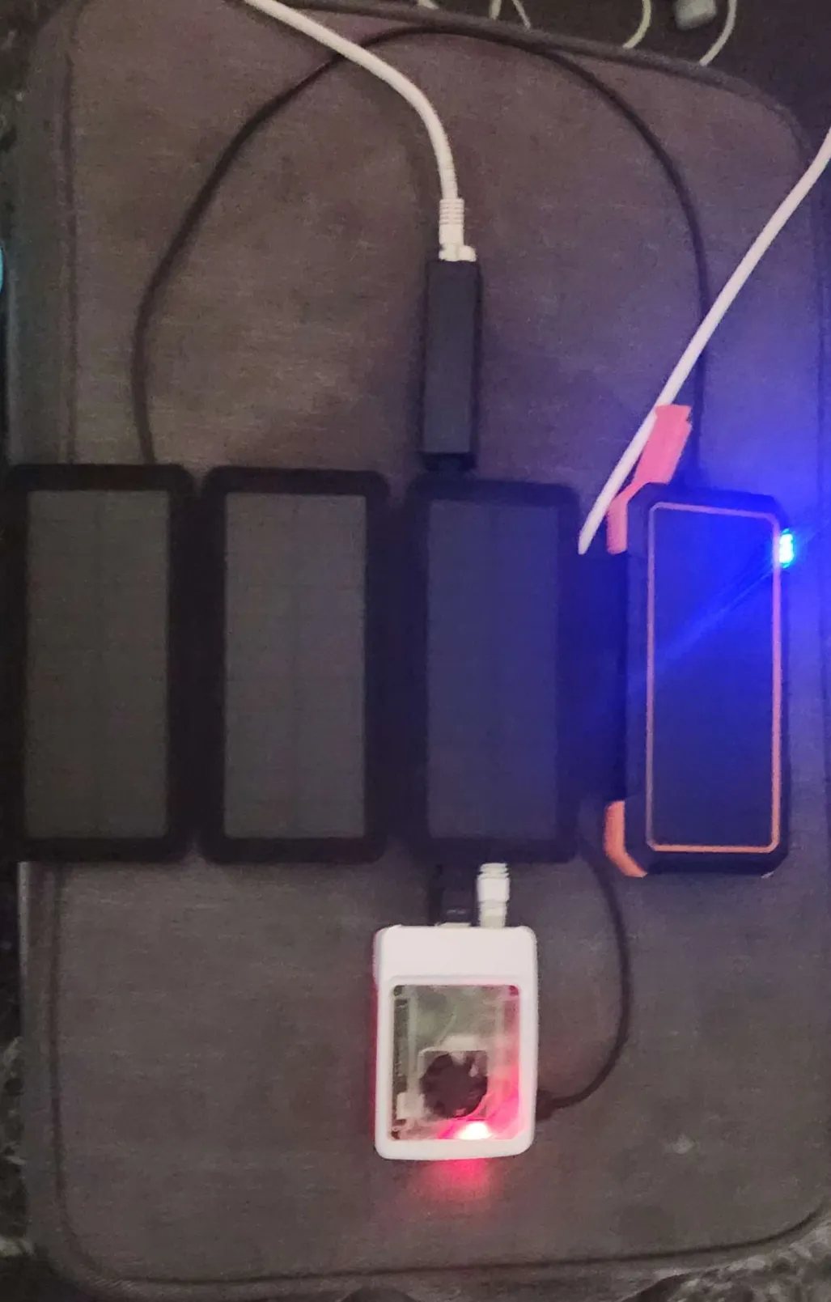Cooled by: Case fan

For connectivity: Usb to Ethernet adapter, wireless dongle, inbuilt Wi-Fi radio and onboard ethernet too.

Powered by: 20000mah battery pack

#### Raspberry Pi Draw:

|  |  |  |
| --- | --- | --- |
| Test | Average Draw over 2hrs | Extra Notes/ OBS |
| A control | 3w | Control Test / Idle on OpenWrt |
| B running | 4w | Default Settings functioning as a mesh router for one device |
| C running with wireless radios 180mbps | 5w | Full Network Load functioning as mesh router |
| D running with cables 1gbps | 5w | Full Network Load functioning as mesh router |

#### Battery Usage:

What Battery Used: 5v 2.4a , 20000mah battery pack

Solar Pannel Used: 4 5w, 5v solar panels

### Complications:

Having done work with raspberry pi5 is also worth to note that it has only one wireless network radio that would require upgrading and a separate antenna for ranged use. The power requirements for the antennae would also affect the power consumption of the device.

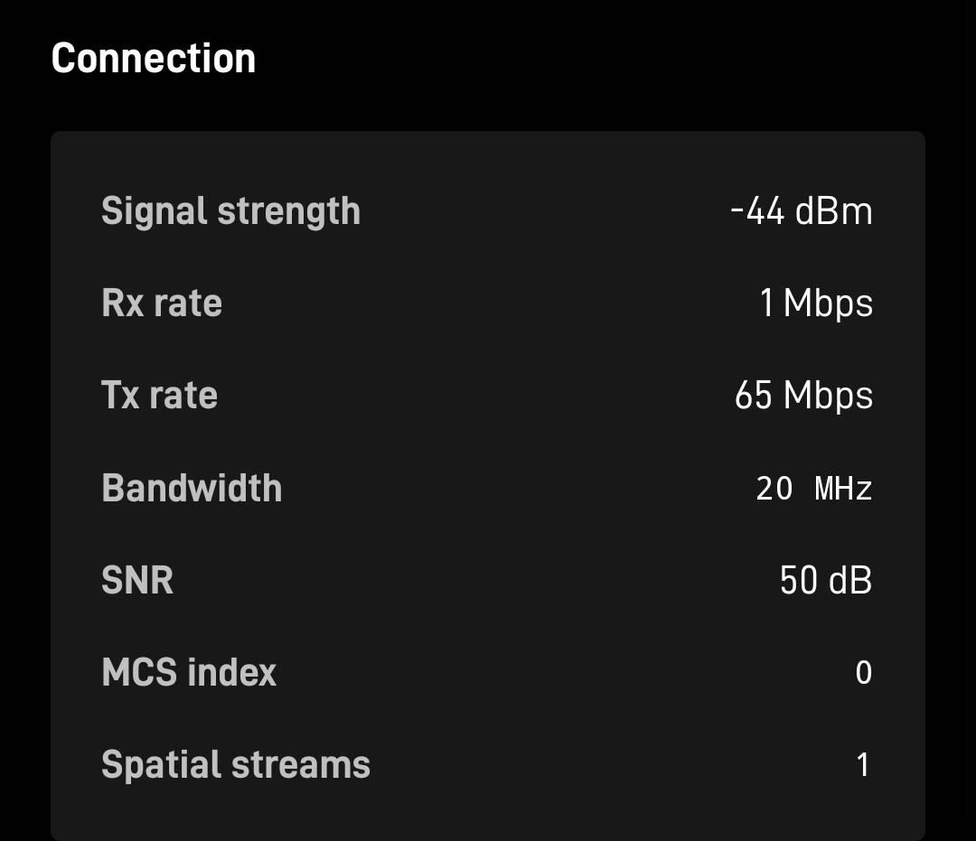

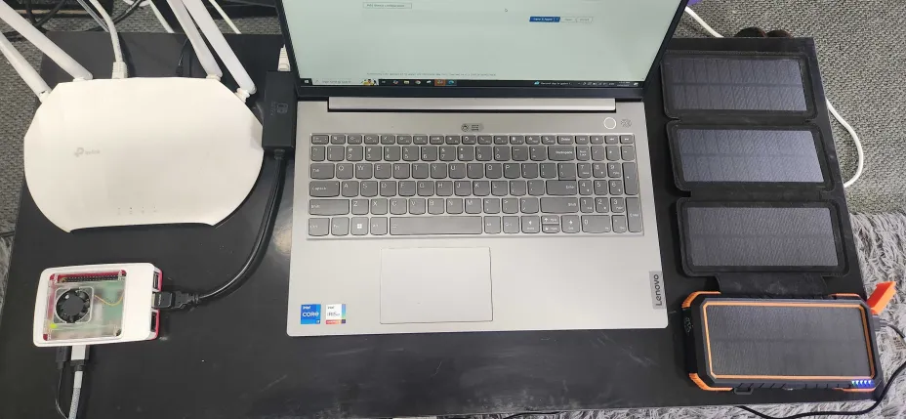

## Discussions:

How much Raspberry Pi 5 draws running open wrt: 3w on idle to a max of 5w on full load

Do the battery estimates meet requirements: the battery estimates were significantly higher than what was required of the pi. 5*9*1000/5 = 9000 mAh being what is required of the pi5.

Whilst running open wrt with significant network load (was only able to test what the hardware was capable off, which was significantly higher on the cable for the sake of tests i did both cable and wireless radio. As a proper setup would include an antenna rather than a Wi-Fi dongle and a wireless radio inbuilt to the pi5.

What size solar Pannel is required to charge this: Roughly a 25w Pannel would be suffice or multiple smaller ones in conjunction with the minimum being about 20w total.

## Conclusions and Recommendations:

In conclusion the expected draw of a pi5 is about 5w running openwrt and functioning as a mesh router. You can expect a change in power draw if you add more external components eg an antenna, however for the sake of this prototype, 20w of solar panels and a 20000mah battery will suffice in powering the pi5 for 24/7 under good conditions.

Additional considerations to account for is weather and long lowlight periods in general. This can be considerably offset by using a 25w solar panel or larger to generate more under lower conditions.